The assassination that brought Europe into a war
Data-based question

Name︰_______________ （ ） Class︰__________

Related Textbook Content | 3A pp. 20-21

Watch the video below and answer the following questions.

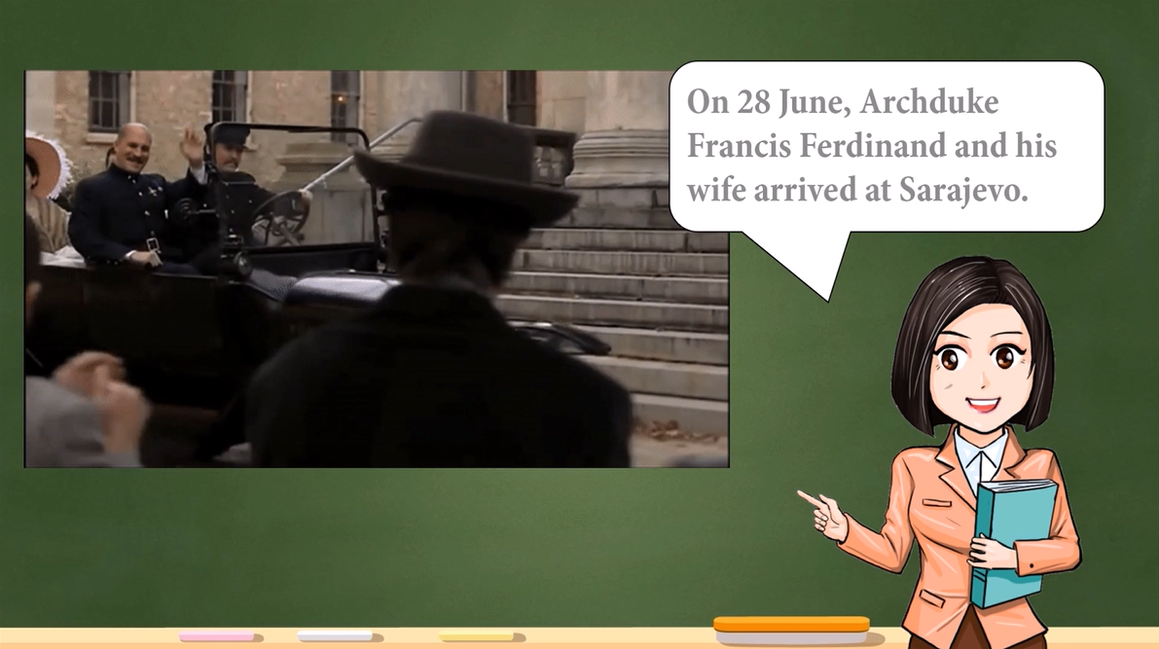
Link: https://youtu.be/_l5Aj5M_FzM  Duration: 3m 07s  Introduction: Introduce how the assassination of Archduke Ferdinand led to the outbreak of WWI. | 

Choose the correct answers and put them in the boxes.

1. | Which of the following statements about Archduke Ferdinand is correct?  A. He was the heir to the Austrian throne.  B. He hated the Germans.  C. He ignored the warning of an assassination.  D. He was killed by a car accident.
2. | Which of the following statements about Gavrilo Princip is correct?  A. He lived in Serbia.  B. He joined a radical anti-Austrian group in secret.  C. He threw a bomb at Archduke Ferdinand.  D. He was arrested after the First World War broke out.

Answer the following questions with reference to the video.

3. Why did Austria Hungary declare war on Serbia?
________________________________________________________________________
________________________________________________________________________

4. Why did the Sarajevo Incident develop into a European war?
________________________________________________________________________
________________________________________________________________________

Answers

1. A

2. B

3. Because Serbia did not respond to the ultimatum sent by Austria-Hungary before the deadline.

4. Because Serbia and Austria-Hungary had dragged their allies into the conflict.

